Shri Vaishnav Vidyapeeth Vishwavidhayala
Indore(MP)

Department of computer science and engineering


Banking Management System(BMS)
Software Requirement Specification Document

Date : March 19,2019

Project Guided By :
Prof.Gurpreet Singh
Project submitted by:
Aashi Gupta(CSE(CMCI))-18100BTCMCI02933
Aayushi Shah(CSE(CMCI))-18100BTCMCI02935
Aadarsh Vyas(CSE(CMCI))-18100BTCMCI04466
Harsh Agrawal(CSE(CMCI))-18100BTCMCI02949
Harsh Mathur(CSE(CMCI))-18100BTCMCI02950
Harshita Lashkari(CSE(CMCI))-18100BTCMCI02951
Kritik Pancholi(CSE(CMCI))-18100BTCMCI02955
Ritik Birla(CSE(CMCI))-18100BTCMCI02969

Banking Management System
(BMS)

Software Requirement Specification Document V 1.0
Table of Contents

Disclaimer 5
1.Introduction…………………………………………………….5
2. Scope 7
3. Assumptions 8
4. Management Summary 9
5.System Objectives & Overview…………………………….10
6. Functional Requirements 11
7. Use Case Diagram 14
7.1.1.To Login functional requirement: 15
7.1.1.1 Input 15
7.1.1.2 Process 15
7.1.1.3 Output: System provides role based access to the BMS. 15
Branch Manager / Authorized Bank Employee – To maintain Banking details. To approve Banking requests, discontinuation requests, get various analytical reports. 16
7.1.2.1 Input 16
7.1.2.2 Process 16
7.1.2.3 Output 16
7.1.3.1 Input 17
7.1.3.2 Process 17
7.1.3.3 Output 18
7.1.4 Discontinue Banking allocation functional requirement: 18
7.1.4.1 Input 18
7.1.4.2 Process 18
7.1.4.3 Output 19
7.1.5 Maintain Banking details functional requirement: 19
7.1.5.1 Input 19
7.1.5.2 Process 19
7.1.5.3 Output 19
The system maintains the Banking details in the centralized database. 20
7.1.6.2 Process 20
7.1.6.3 Output 20
8. Database Schema 20
1. Banking Details: 20
a) Banking ID (uniquely assigned by the system) 20
b) Banking Size / Specification 20
c) Banking Type 20
d) Banking Physical location 20
e) Banking Status 20
a) Request ID (uniquely assigned by the system) 20
b) Request Date 20
c) Request Status 20
d) Customer ID 20
e) Requested Banking Type 20
f) Requested Banking Physical Location 20
g) Requested Banking Branch 20
i) Banking Operator 20
j) Contract date 20
9.Working……………………………………………………21
10.Security……………………………………………………24

Disclaimer

This Software Requirements Specification document is a guideline. The document details all the high level requirements. The document should be used as a guideline by the students to design the Solution Architecture for the project-“The Banking Management System”. The document also describes the broad scope of the project and high level DB requirements are captured in the DB specification. But while developing the solution if the developer has a valid point to add more details being within the scope specified then it can be accommodated after consultation.

1.Introduc tion

The” Banking management system” project is a model Internet Banking Site. This Site enables the customers to perform the basic banking transactions by sitting at their office or at homes through PC or laptop. The system provides the access to the customer to create an account, deposit/withdraw the cash from his account, also to view reports of all accounts present. The customers can access the banks website for viewing their Account details and
perform the transactions on account as per their requirements. With Internet Banking, the brick and mortar structure of the traditional banking gets converted into a click and portal model, thereby giving a concept of virtual banking a real shape.

The primary aim of this “Banking Management System” is to provide an improved design methodology, which envisages the future expansion, and modification, which is necessary for a core sector like banking.

2.Scope

This document describes the scope of the requirements for the Banking Management System ( BMS ) for SVVV Co-operative Bank. The document details all the high level requirements with intent to validate SVVV Co-operative Bank requirements. This document should be used by the Architect and the developers to design the Solution Architecture for the project. In addition to this, the document also describes the broad scope of the project. The scope of the project involves the integration of a subset of all the components of current IT environment. The Banking Management System ( BMS ) should interface with the existing Customer Management , Savings Account System , Current Account System, FD account Management ,Deletion of Account, Loan Management System , Transaction Management.

The system must maintain central data for all Bankings, Banking requests, Banking allocations, customer Banking contracts, complaints and Banking payments. There is also the need to have an interface with the existing different types of Accounts, Employee and Customer Management System to validate customer and fund transfer for Banking payments. The scope of the project also involves the development of the interfaces with the existing Customer, Employee Management and different types of Account systems that validates the customer and helps in direct fund transfer for the Banking transactions.
3. Assumptions

The following are the assumptions for this document
- The Branch Manager / Authorized Bank Employee is responsible for Banking allocation.
2. The system also has an interface with the Customer, Employee Management and different types of Accounts system which validates the customer and helps in direct fund transfer for the Banking transactions.
3. Only Registered customer can browse / search for Banking and have an access to Banking Transactions & unregistered customer can go for registration in the bank for the account creation & further processing .
- Software developers must consider the existing Customer, Employee Management and different types of Accounts system and interface with these when designing this solution, since there must be seamless integration with these systems.

4. Management Summary

SVVV Co-operative Bank is a leading co-operative bank in India. SVVV Co-operative Bank is trying to expand their business and would like to provide various services online. One of the most in demand service is online services . Bank customers are provided with the facility of Bankings, available in various types .
Currently, the customers have to visit the Bank physically to apply for the Banking. Many customers have expressed wastage of time in application, Banking charges payment, complaint registration -etc. Some of the customers have also questioned the transparency of Banking allocation.

5. System Objectives / Overview
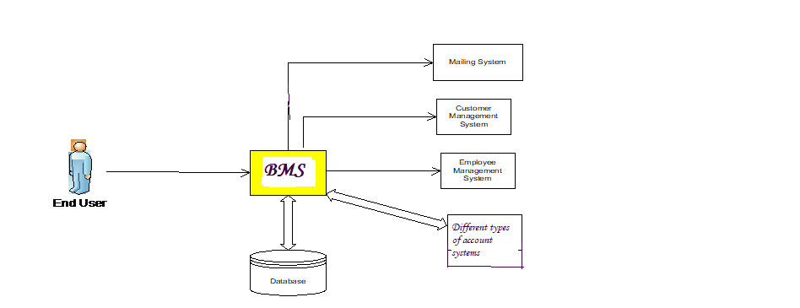

Figure 1 System Context Diagram

The diagram above explains the main conceptual elements in the solution and their relationships with the architecture. The Banking Management System (BMS) component interacts with the Customer, Employee Management System and different types of Account System. These systems receives requests Customer validation and fund transfer at the time of various Banking transactions. The Branch Manager / Authorized Employee will maintain Banking details through the system which in turn will be accessed by the registered customers & unregistered customers.

Banking Management System ( BMS ) |  | Banking Management System which is to be developed. It manages all the online Banking Transactions of SVVV Co-operative Bank by interfaces with the existing , creation of different types of account systems & Customer Management System to perform customer validation and fund transfer for Banking transactions.

DBMS | Centralized Repository that need to be maintained to enable BMS to operate efficiently to provide accuracy and swift response
Notification System | A system which sends automated notification to the registered customer who has requested for Banking on allocation of accounts, for renewal of accounts and for complaint status.
Different types of Account Systems | Existing & creation of new different types of Account Systems that maintains Accounts details.
Customer Management System | Existing & new Customer Management System that maintains Customer details.
Employee Management System | Existing Employee Management System that maintains Employee details.

6. Functional Requirements

The high level functional requirement for the Banking Management System ( BMS ) for SVVV Co-operative Bank is represented in the Use Case diagram shown below. The remaining sections in the document describe the major use cases.
Following are the identified functional requirements of the BMS System
Provide role based access to the system ( Authentication and Authorization)
  - Branch Manager / Authorized Bank Employee – To Login and maintain Banking details. To approve account requests, discontinuation requests, get various analytical reports.
  - Registered Customer – To Login and perform various Banking transactions - request for account, renewal of account, application of discontinuation, compliant registration.

7. Use Case Diagram

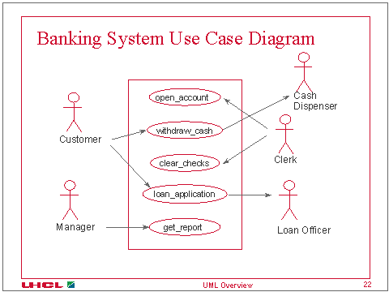
7.1 . Detail Description of Use Cases

7.1.1.To Login functional requirement:

7.1.1.1 Input
Branch Manager / Authorized Bank Employee, Registered Customer of the Bank feed in UserName and Password or MPIN.
7.1.1.2 Process
The system on receiving the details validates it with an interface with the Customer and Employee Management System and provides role based access to the BMS.

7.1.1.3 Output

System provides role based access to the BMS.Branch Manager / Authorized Bank Employee – To maintain Banking details. To approve Banking requests, discontinuation requests, get various analytical reports.
Registered Customer – To Login and perform various Banking transactions - request for Banking, renewal of Banking, application of discontinuation, compliant registration.

7.1.2 Request / Apply for Banking functional requirement:

7.1.2.1 Input
Valid login by Registered Customer of Bank or user can register themselves by the account creation option available for the unregistered user.
7.1.2.2 Process
Customer chooses the account from the Banking list, system displays the Banking details like deposit , credit , transactions ,
Loan applications , fd creation ,salary status,transaction history & further details related to banking .
7.1.2.3 Output
The system saves and updates the account request, generates auto-mailer for approval to the Branch Manager / Authorized Bank Employee.

7.1.3 Allocate Banking functional requirement:

7.1.3.1 Input
Branch Manager / Authorized Bank Employee valid login and account allocation details. Registered Customer valid login and submission of required details for account contract.

7.1.3.2 Process
Branch Manager / Authorized Bank Employee login and allocates the account. The system updates the account request status as “Allocated, Contract pending” and sends an auto-mailer to the respective requester to complete the process formalities.
7.1.3.3 Output
The system updates the account request, generates auto-mailer for approval, contract documentation, account allocation and fund transfer to the Branch Manager / Authorized Bank Employee and respective requester.

7.1.4 Discontinue Banking allocation functional requirement:
7.1.4.1 Input
Registered Customer valid login and request for banking discontinuation.

7.1.4.2 Process
The Registered customer submits an application / request for Banking discontinuation through the BMS system online. System sends an auto-mailer to the Branch Manager / Authorized Bank Employee approves the discontinuation of the facility on cross checking against balance payment for the Banking, if System updates the Banking Allocation status as “Discontinued” .
7.1.4.3 Output
The system add a new item in the Item Listing.

7.1.5 Maintain Banking details functional requirement:
7.1.5.1 Input
Branch Manager / Authorized Bank Employee valid login and maintain Banking details.

7.1.5.2 Process
The systems on receiving this request validates the user with the Employee management System and allows the user to maintain Banking details .

7.1.5.3 Output

The system maintains the Banking details in the centralized database.

7.1.6 Get Analytical Reports functional requirement:
7.1.6.1 Input
Branch Manager / Authorized Bank Employee valid login and get various analytical reports.

7.1.6.2 Process
The systems on receiving this request validates the user with the Employee management System and allows the user to get various Analytical Reports such as – account Request status report, Banking Requests for a month, Defaulter account holder list -etc.

7.1.6.3 Output
The system displays various Analytical Reports as requested.

8. Database Schema

The proposed database schema is as follows:

Banking Details:

Account ID (uniquely assigned by the system)

b) Account Type

c) Account Status

2. Banking Request

Request ID (uniquely assigned by the system)

Request Date

Request Status

Customer ID

Requested account Type

Requested Banking Branch
g)Request Approved by ( Employee ID who approves the request )

9.Working
The user login to the “The Banking Management System” first then he will be provided with the three options .
1.To logged in to his existing account .
- User or an existing account holder is provided with an username, password or MPIN with which he can logged in to his account prform futher oprations .
- The user can be able to number of operations like different types of transactions (NEFT,RTGS) , deposit & withdrawal .

- 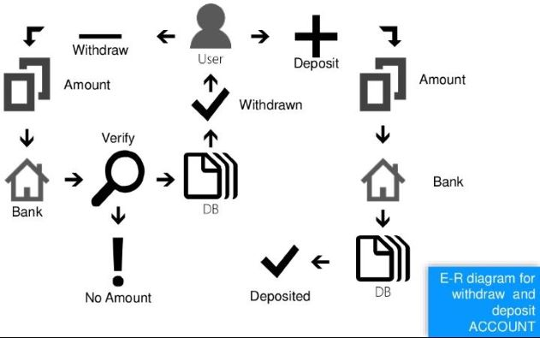

- apply for an loan , apply for an locker and many more.
- The user can also apply for deletion of his account.

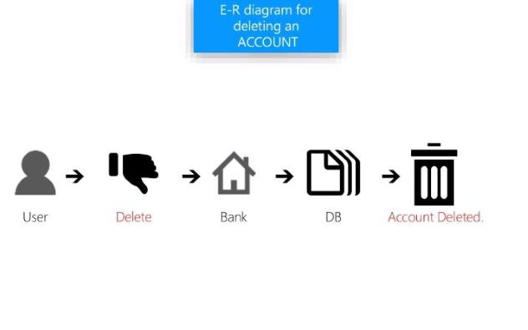

2.To apply for an account.
- If the user does not have any existing account then he can apply for an account of any type from the options given(current ,saving ,fd etc)
- As user apply for an account all the mendatory details should be filled by the customer itself.
- After the form submission customer should cliclk on apply option then only his request will be proceeded.
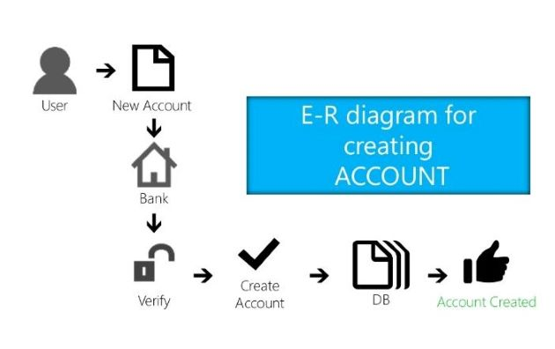

3.Third option is that if user is an bank employee then he can login with the employee id allotted to him.
- So he can login with the particular user id allotted to him .
- He can see the customers info & modify if required & he is also an authorized person who will verify the user’s details & can approve customers request.
10.Security
The most important requirement in any banking system is the security . The user should be provided with the secure & protected environment for the safe & sound banking .
11.Program Code

#include <iostream.h>
#include<fstream.h>
#include<conio.h>
#include<string.h>
#include<stdio.h>
#include<graphics.h>
#include<dos.h>
#include<stdlib.h>
#include<math.h>
#include<iomanip.h>
class Bank
{
public:
long int damount;
char dob[9],Phone[11],adharno[13],panno[11],voterno[11],drivingno[16];
char name[10],fname[10],address[10];
char code[15],pass[9];
void read();
void display();
void accgen();
void password();
void searchdata(char *,char *);
void searchdata2(char *,char *);
void searchdata3(char *,char *);
void searchdata4(char*);
int storedata();
void display2();
void display3();
void dname();
void ldisplay();
int accver(char *,char*);
void lsearchdata(char *,char *);
void deposit_withdraw(char *, int );
void dep(int );
void draw(int );
int retdeposit();
};

void main()
{
int gd=DETECT,gm;
initgraph(&gd,&gm,"c:\\tc\\bgi");
rec();
welcome();
rec();
load();
rec();
cleardevice();
useremployee();
getch();
closegraph();
}

void rec(void)
{
for(int i=0;i<400;i++)
{
setcolor(0);
delay(1);
rectangle(getmaxx()/2-i,getmaxy()/2-i,getmaxx()/2+i,getmaxy()/2+i);
}
cleardevice();
}

void welcome()
{
layout();
setcolor(1);
setfillstyle(1,BLUE);
rectangle(8,11,632,80);
floodfill(9,21,1);
setcolor(15);
rectangle(2,5,638,473);
rectangle(6,9,634,469);
setcolor(14);
setfillstyle(1,YELLOW);
rectangle(8,430,632,466);
floodfill(9,440,14);
setbkcolor(7);
//traingle
setcolor(LIGHTBLUE);
setfillstyle(SOLID_FILL,LIGHTBLUE);
line(10,90,420,430);
line(10,430,420,430);
line(10,92,10,430);
floodfill(20,400,LIGHTBLUE);
//rectangle
setcolor(WHITE);
setfillstyle(SOLID_FILL,WHITE);
rectangle(200,130,400,330);
floodfill(201,140,WHITE) ;
//logo
setcolor(BLACK);
rectangle(249,285,349,298); //small rectangle
rectangle(219,298,379,311); //big rectangle
line(244,200,354,200); //roofbottom
line(265.5,192,333.5,192); //roof upper
line(244,200,299,150); //triangle right
line(265.5,192,299.5,162); //small triangle right
line(354,200,299,150); //triangle left
line(299.5,162,333.5,192); //small triangle left
line(253,285,253,200); //1
line(345,285,345,200); //last
line(263,285,263,200); //2
line(273,285,273,200); //3
circle(299,242.5,18);
line(283,249,283,285); //4 line lower
line(283,234,283,200); //4 line upper
line(293,200,293,226); //5 line upper
line(293,259,293,285); //5 line lower
line(303,200,303,226); //6 line upper
line(303,259,303,285); //6 line lower
line(313,200,313,231); //7 th line upper
line(313,254,313,285); //7 th line lower
line(323,200,323,285); //8th line lower
line(333,200,333,285); //9th line lower
arc(294,240.5,298,58,8);
line(296,242,304,242); //middle
line(294,234,304,234); //top
line(297,248,303,254); //R KE niche wali line
//welcome
setcolor(15);
settextstyle(7,0,6);
outtextxy(180,350,"WELCOME");
getch();
}

void load(void)
{
cleardevice();
layout1();
setcolor(BLUE);
setfillstyle(SOLID_FILL,BLUE);
circle(300,230,100);
floodfill(301,230,BLUE);
setcolor(WHITE);
rectangle(260,270,350,280); //small rectangle
rectangle(220,280,390,290); //big rectangle
line(380,200,230,200); //roofbottom
line(250,193,350,193); //roof upper
line(230,200,300,150); //triangle right
line(250,193,300,162); //small triangle right
line(380,200,300,150); //triangle left
line(350,193,300,162); //small triangle left
line(229,280,229,200); //1
line(380,280,380,200); //last
line(249,280,249,200); //2
line(360,280,360,200); //second last
line(269,270,269,200); //3
line(340,270,340,200); //third last
circle(300,235,22);
line(280,270,280,230); //3rd line lower
line(280,200,280,228); //3rd line upper
line(320,270,320,243); //last third line lower
line(320,200,320,228); //last third line upper
line(290,200,290,215); //4 line upper
line(290,270,290,254); //4 line lower
line(300,200,300,213); //5 line upper
line(300,270,300,257); //5 line lower
line(310,200,310,214); //6 line upper
line(310,270,310,255); //6 line lower
arc(300,233,290,58,8);
line(300,235,315,235); //middle
line(300,227,315,227); //top
line(300,242,310,248); //R KE niche wali line
int i=0,z=0;
setcolor(8);
settextstyle(3,0,3);
setcolor(15);
rectangle(75,350,540,375);
setcolor(2);
while(i<450)
{
delay(410);
gotoxy(37,25);
circle(299,390,15);
cout<<z<<"%";
rectangle(80+i,355,86+i,370);
i+=9;
z+=2;
}
sound(140);
delay(99);
nosound();
}

void layout(void)
{
int gd=DETECT,gm;
initgraph(&gd,&gm,"c:\\tc\\bgi");
setcolor(1);
setfillstyle(1,BLUE);
rectangle(8,11,632,80);
floodfill(9,21,1);
setcolor(15);
settextstyle(1,0,8);
outtextxy(80,0,"Svvv Bank");
logom();
setcolor(15);
rectangle(2,5,638,473);
rectangle(6,9,634,469);
setcolor(14);
setfillstyle(1,YELLOW);
rectangle(8,440,632,466);
floodfill(9,450,14);
}

void logom(void)
{
//small logo start code
rectangle(500,69,545,74); //upper rectangle
rectangle(493,74,552,79); //lower rectangle
line(495,38,550,38); // big triangle base line
line(495,38,522.5,15); //big triangle left
line(550,38,522.5,15); //big rectangle right
line(507,34,538,34); //small triangle base line
line(507,34,522.5,21); //small triangle left
line(538,34,522.5,21); //small triangle right
line(503,69,503,38); // 1st line
line(542,69,542,38); //last line
line(509,69,509,38); //2nd line
line(536,69,536,38); //2nd last line
line(514,69,514,61); // 3rd line lower
line(514,38,514,47); //3rd line upper
line(520,69,520,63); //4th line lower
line(520,38,520,42); //4th line upper
line(526,69,526,64); //5thline lower
line(526,38,526,43); //5th line upper
line(531,69,531,59); // 6th line lower
line(531,38,531,47); //6th line upper
circle(522.5,53.5,10);
arc(519.5,53.5,297,58,4);
line(519.5,56.5,523,60); // r ke niche wali line
line(518,49,524.5,49); //top line
line(520,53.5,524.5,53.5); //middle
//small logo ends
}

void useremployee()
{
cleardevice();
layout1();
part();
char ch;
gotoxy(41,23);
cin>>ch;
switch(ch)
{
case '1':
rec();
login();
break;
case '2':
rec();
loginin();
break;
}
}

void layout1(void)
{
setcolor(1);
setfillstyle(1,BLUE);
rectangle(8,11,632,80);
floodfill(9,21,1);
setcolor(15);
settextstyle(1,0,8);
outtextxy(80,0,"Svvv Bank");
logom();
setcolor(15);
rectangle(2,5,638,473);
rectangle(6,9,634,469);
setcolor(14);
setfillstyle(1,YELLOW);
rectangle(8,440,632,466);
floodfill(9,450,14);
}

void login()
{
cleardevice();
layout();
Bank objs;
setcolor(8);
setfillstyle(1,DARKGRAY);
rectangle(10,83,190,436);
floodfill(16,210,8);
setcolor(0);//user logo design start
setfillstyle(1,YELLOW);
circle(83,150,10);
floodfill(84,150,0);
setcolor(0);
arc(82,181,0,180,20);
line(63,181,101,181);//user logo design end
settextstyle(3,0,3);
outtextxy(61,190,"Please");
outtextxy(61,225,"Login");
outtextxy(61,265,"Your");
outtextxy(61,300,"Account");
setcolor(2);
setfillstyle(1,GREEN);
rectangle(193,83,630,436);
floodfill(206,410,2);
setcolor(0);
setfillstyle(1,WHITE);
circle(355,150,35);
floodfill(356,150,0);
setcolor(0);//user logo design start
setfillstyle(1,YELLOW);
circle(355,140,12);
floodfill(351,140,0);
setcolor(0);
arc(355,180,20,161,28);
//line(350,181,450,181);//user logo design end
setcolor(10);
setfillstyle(1,LIGHTGREEN);
rectangle(210,210,500,400);
floodfill(211,220,10);
setcolor(0);
settextstyle(3,0,2);
outtextxy(220,220,"Account No");
setcolor(15);
setfillstyle(1,WHITE);
rectangle(340,216,490,243);
floodfill(341,220,15);
setcolor(0);
settextstyle(3,0,2);
outtextxy(220,260,"Password");
setcolor(15);
setfillstyle(1,WHITE);
rectangle(340,265,490,292);
floodfill(341,275,15);
setfillstyle(1,WHITE);
rectangle(275,325,420,352);
floodfill(276,335,15);
setcolor(0);
setfillstyle(1,WHITE);
rectangle(570,100,620,150);
floodfill(571,110,0);
setcolor(1);
setfillstyle(1,WHITE);
circle(595,128,20);
floodfill(596,128,1);
setcolor(1);
setfillstyle(1,BLUE);
circle(595,128,16);
floodfill(596,128,1);
setcolor(15);
setfillstyle(1,WHITE);
rectangle(595,112,598,130);
floodfill(596,122,15);
int a;
gotoxy(44,15);
gets(acc);
int i;
for(i=0;i<8;i++)
{
gotoxy(44+i,18);
pa[i]=getch();
cout<<"*";
}
pa[i]='\0';
a=objs.accver(acc,pa);
if(a==1)
{
while(!kbhit())
{
setcolor(rand()%13);
delay(250);
settextstyle(3,0,2);
outtextxy(312,322,"Continue");
}
cleardevice();
rec();
objs.dname();
getch();
rec();
login2();
}
else
{
while(!kbhit())
{
setcolor(rand()%15);
delay(300);
settextstyle(3,0,2);
outtextxy(285,320,"Wrong a/c no or password");
}
char cd;
cd=getch();
if(cd=' ')
{
rec();
exit(0);
}
cleardevice();
rec();
login();
}

void loginin(void)
{
cleardevice();
layout();
p1();
char lid[]="Bms3@Team",pa[]="Svvv@BmS",a[30],b[20];
int result1,result2;
setcolor(0);
gotoxy(44,15.5);
gets(a);
result1=strcmp(lid,a);
int i;
for(i=0;i<8;i++)
{
gotoxy(44+i,18);
b[i]=getch();
cout<<"*";
}
b[i]='\0';
result2=strcmp(pa,b);
if(result1==0)
{
if(result2==0)
{

while(!kbhit())
{
setcolor(rand()%13);
delay(250);
settextstyle(3,0,2);
outtextxy(312,322,"Continue");
}
getch();
rec();
cleardevice();
Choice();
}

else
{ while(!kbhit())
{
setcolor(rand()%13);
delay(250);
settextstyle(3,0,2);
outtextxy(312,322,"INVALID PASSWORD");
}

}
}
else
{
while(!kbhit())
{
setcolor(rand()%13);
delay(250);
settextstyle(3,0,2);
outtextxy(312,322,"INVALID USERNAME");
}
getch();
cleardevice();
loginin();
}
}

void p1(void)
{
int gd=DETECT,gm;
initgraph(&gd,&gm,"c:\\tc\\bgi");
setcolor(1);
setfillstyle(1,BLUE);
rectangle(8,11,632,80);
floodfill(9,21,1);
setcolor(15);
settextstyle(1,0,7);
outtextxy(140,1,"Svvv Bank");
//logo();
setcolor(15);
rectangle(2,5,638,473);
rectangle(6,9,634,469);
setcolor(14);
setfillstyle(1,YELLOW);
rectangle(8,440,632,466);
floodfill(9,450,14);
loginm();
getch();
}

void loginm(void)
{
setcolor(8);
setfillstyle(1,DARKGRAY);

rectangle(10,83,190,436);
floodfill(16,210,8);
setcolor(0);//user logo design start
setfillstyle(1,YELLOW);
circle(83,150,10);
floodfill(84,150,0);
setcolor(0);
arc(82,181,0,180,20);
line(63,181,101,181);//user logo design end
settextstyle(3,0,3);
outtextxy(61,190,"Please");
outtextxy(61,225,"Login");
setcolor(2);
setfillstyle(1,GREEN);
rectangle(193,83,630,436);
floodfill(206,410,2);
setcolor(0);
setfillstyle(1,WHITE);
circle(355,150,35);
floodfill(356,150,0);
setcolor(0);//user logo design start
setfillstyle(1,YELLOW);
circle(355,140,12);
floodfill(351,140,0);
setcolor(0);
arc(355,180,20,161,28);
//line(350,181,450,181);//user logo design end
setcolor(10);
setfillstyle(1,LIGHTGREEN);
rectangle(210,210,500,400);
floodfill(211,220,10);
setcolor(0);
settextstyle(3,0,2);
outtextxy(220,220,"Login ID");
setcolor(15);
setfillstyle(1,WHITE);
rectangle(340,216,490,243);
floodfill(341,220,15);
setcolor(0);
settextstyle(3,0,2);
outtextxy(220,260,"Password");
setcolor(15);
setfillstyle(1,WHITE);
rectangle(340,265,490,292);
floodfill(341,275,15);
setfillstyle(1,WHITE);
rectangle(275,325,420,352);
floodfill(276,335,15);
setcolor(0);
setfillstyle(1,WHITE);
rectangle(570,100,620,150);
floodfill(571,110,0);
setcolor(1);
setfillstyle(1,WHITE);
circle(595,128,20);
floodfill(596,128,1);
setcolor(1);
setfillstyle(1,BLUE);
circle(595,128,16);
floodfill(596,128,1);
setcolor(15);
setfillstyle(1,WHITE);
rectangle(595,112,598,130);
floodfill(596,122,15);
}

12.Project Screenshots

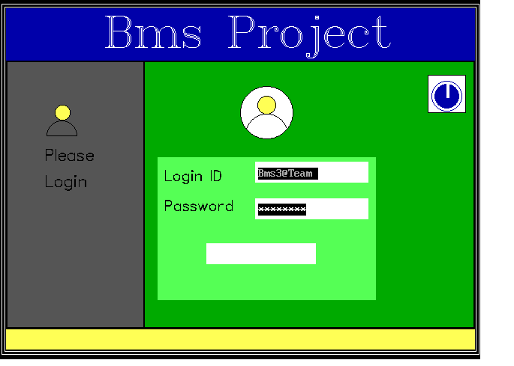

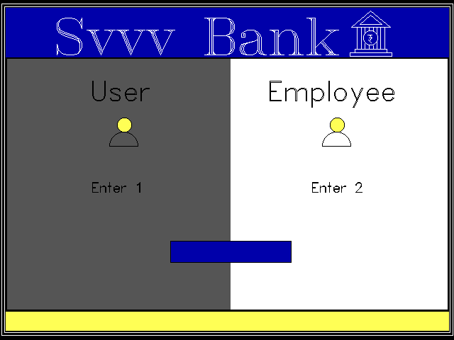

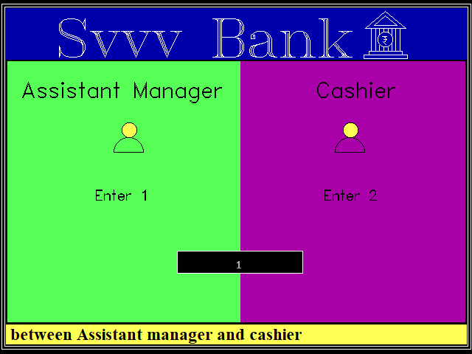

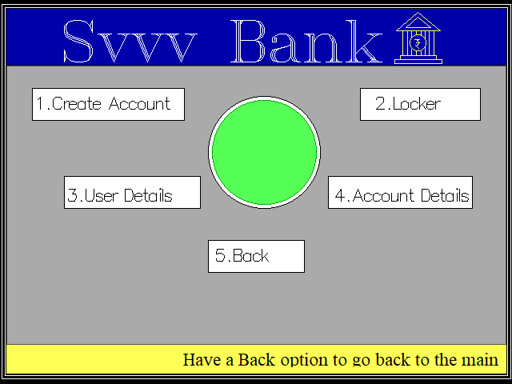

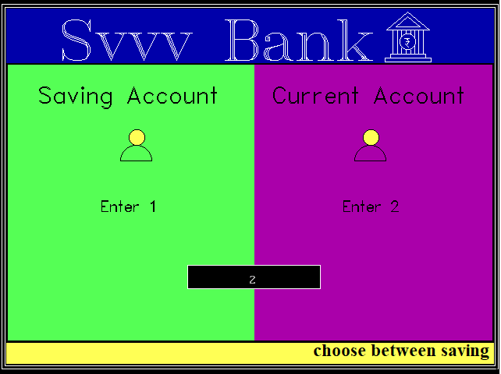

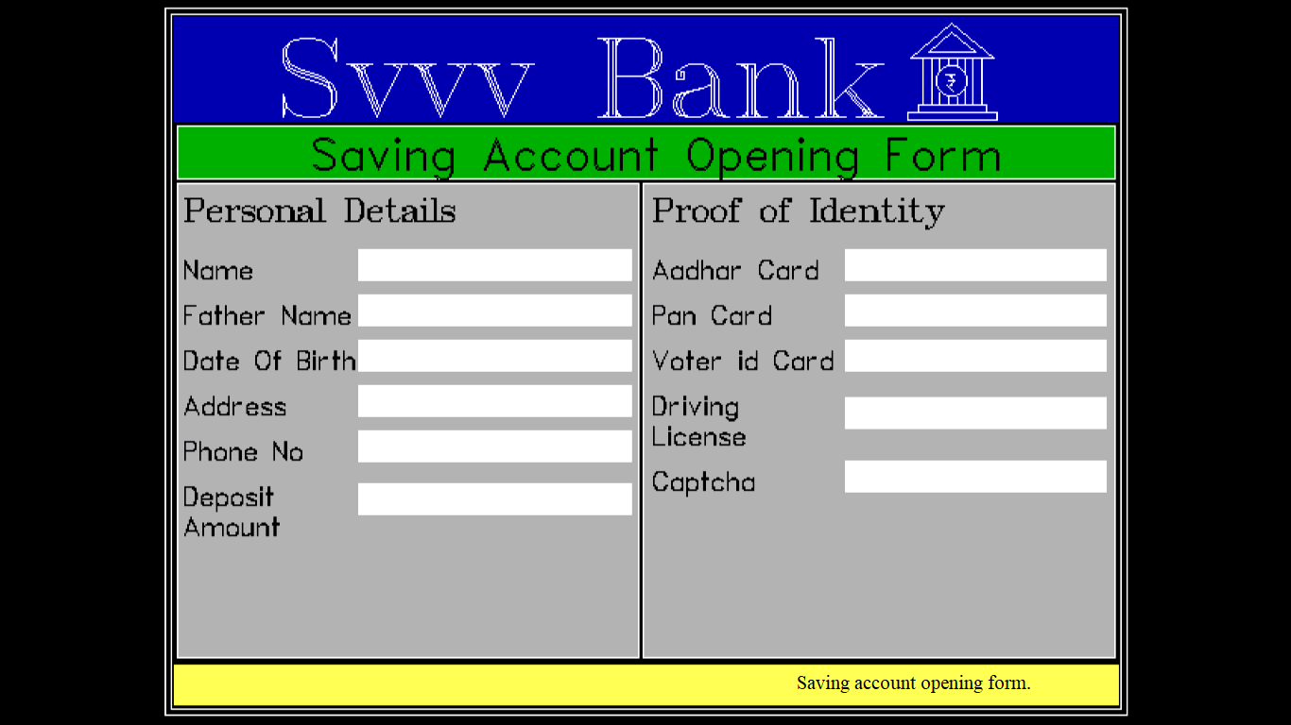
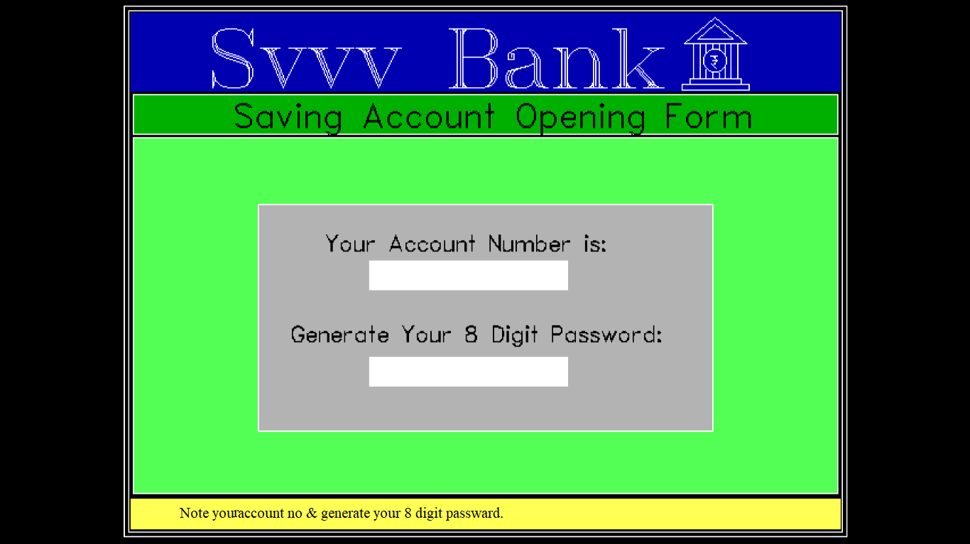
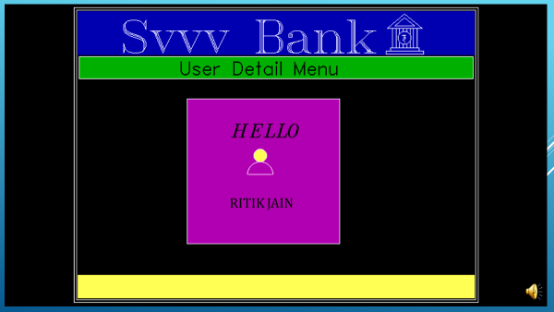

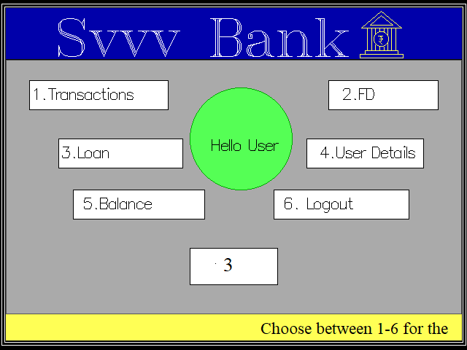

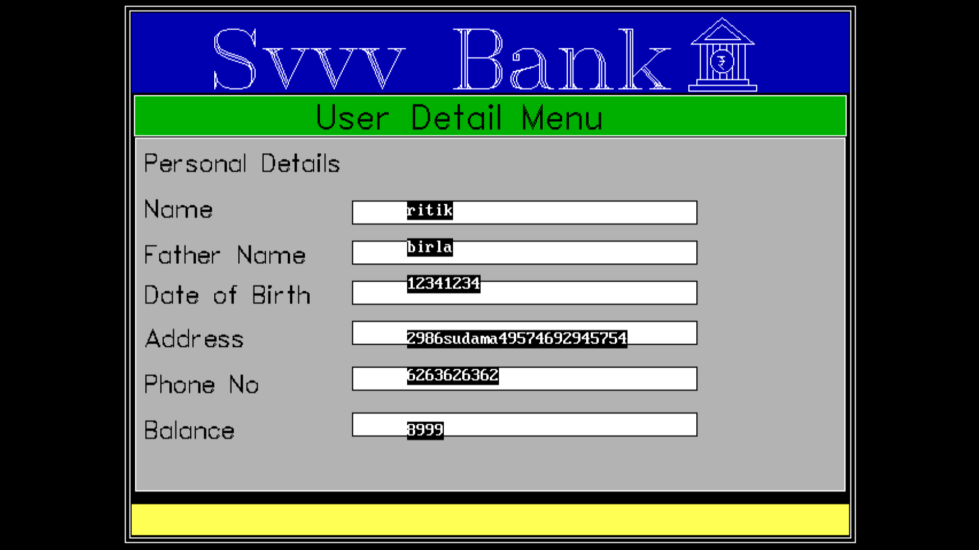

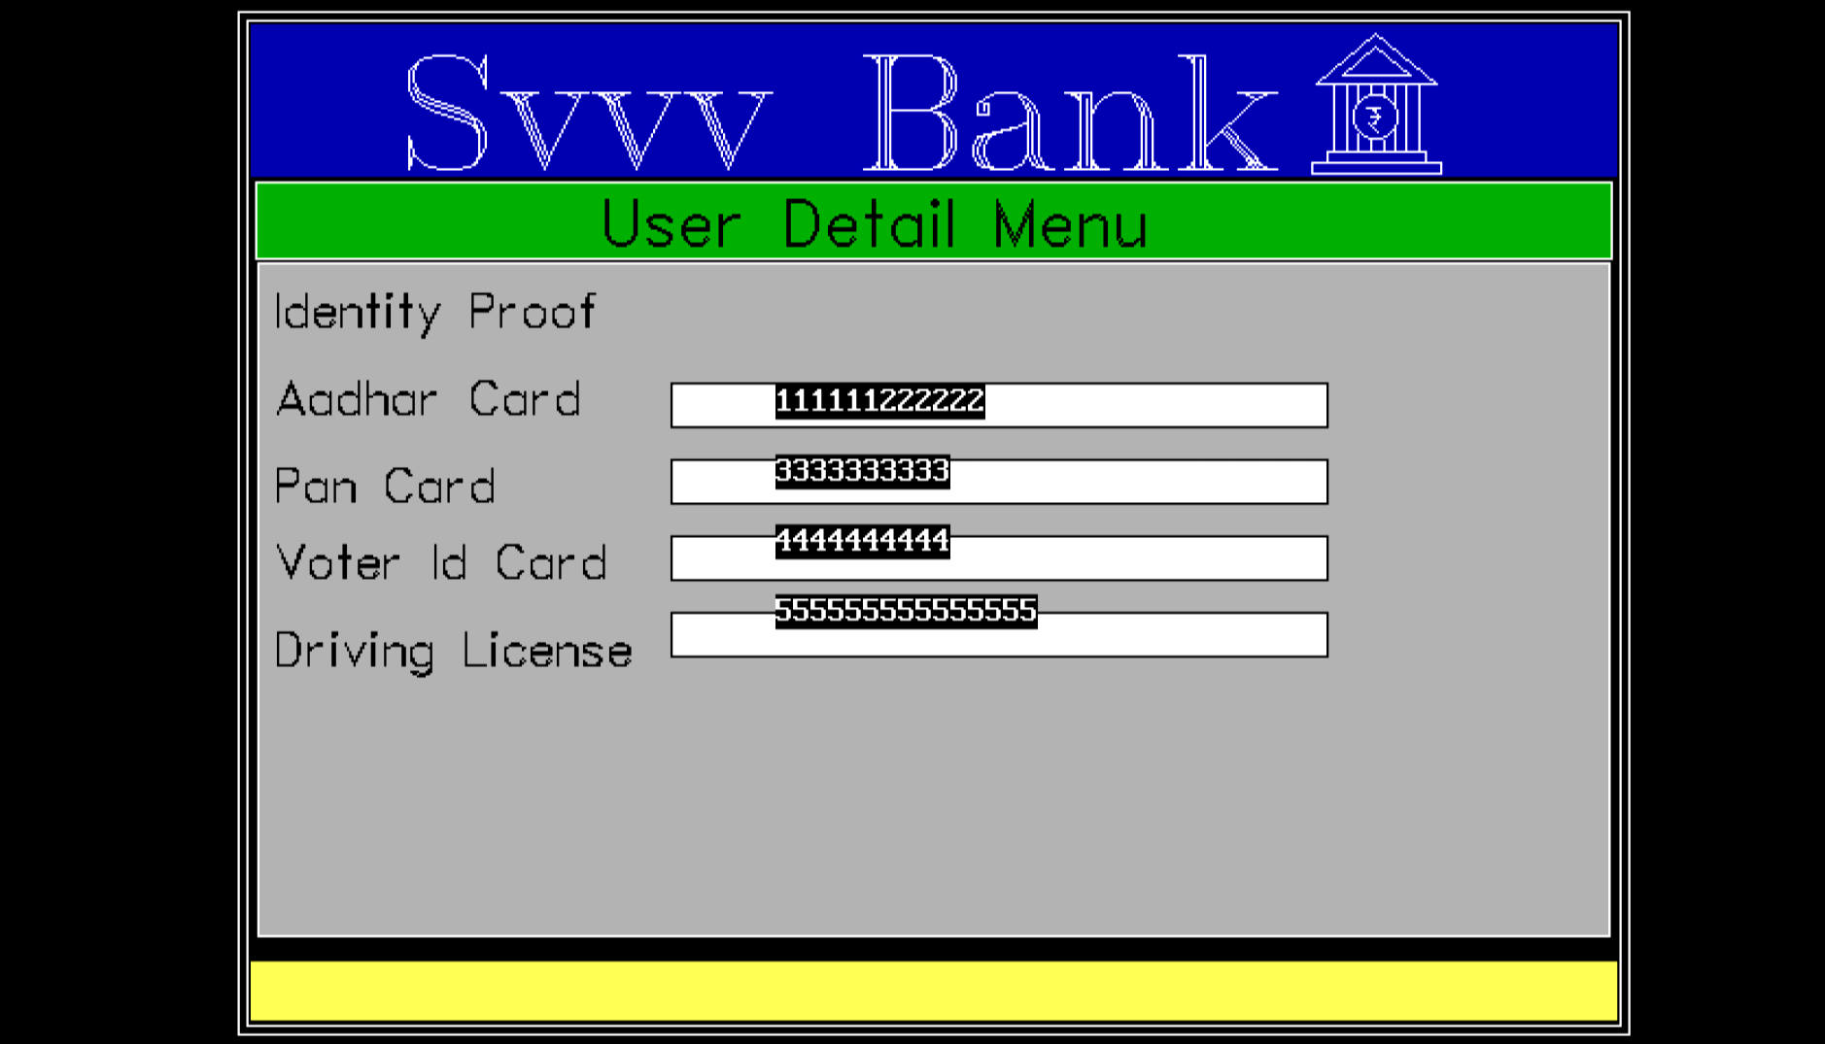

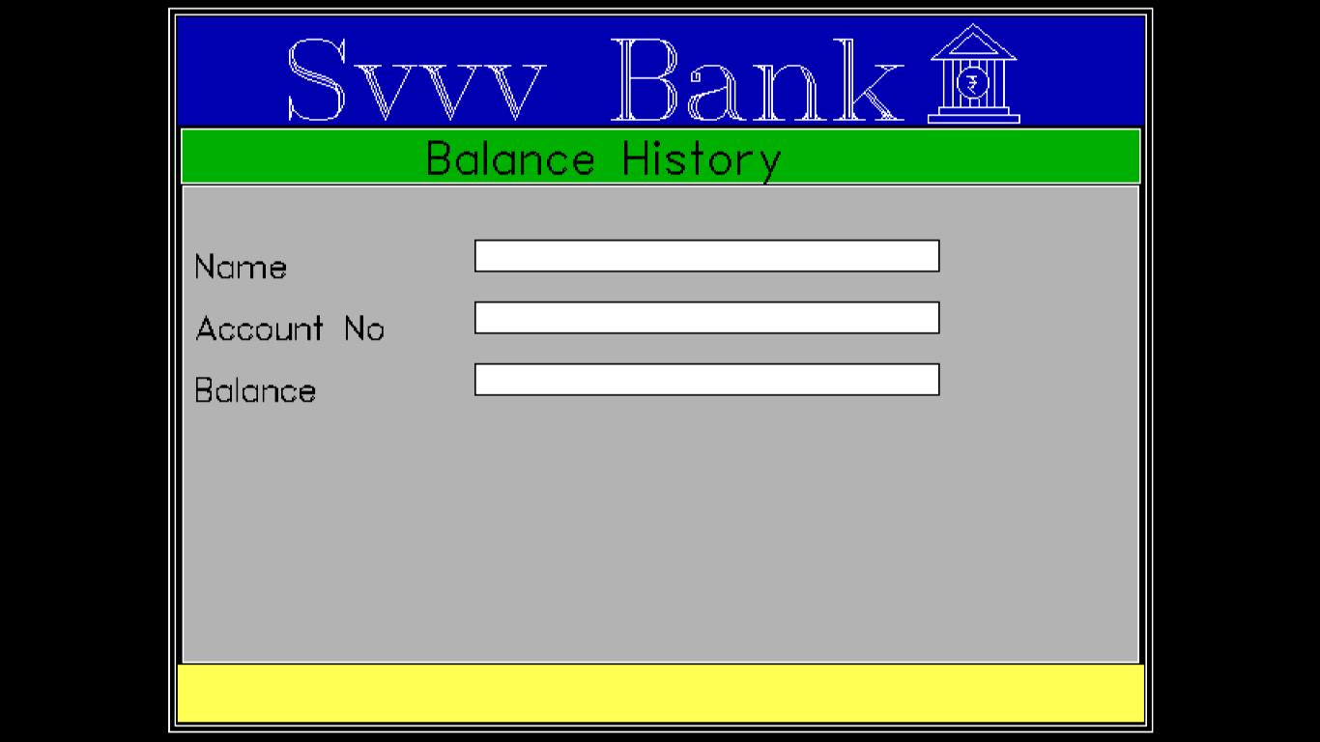

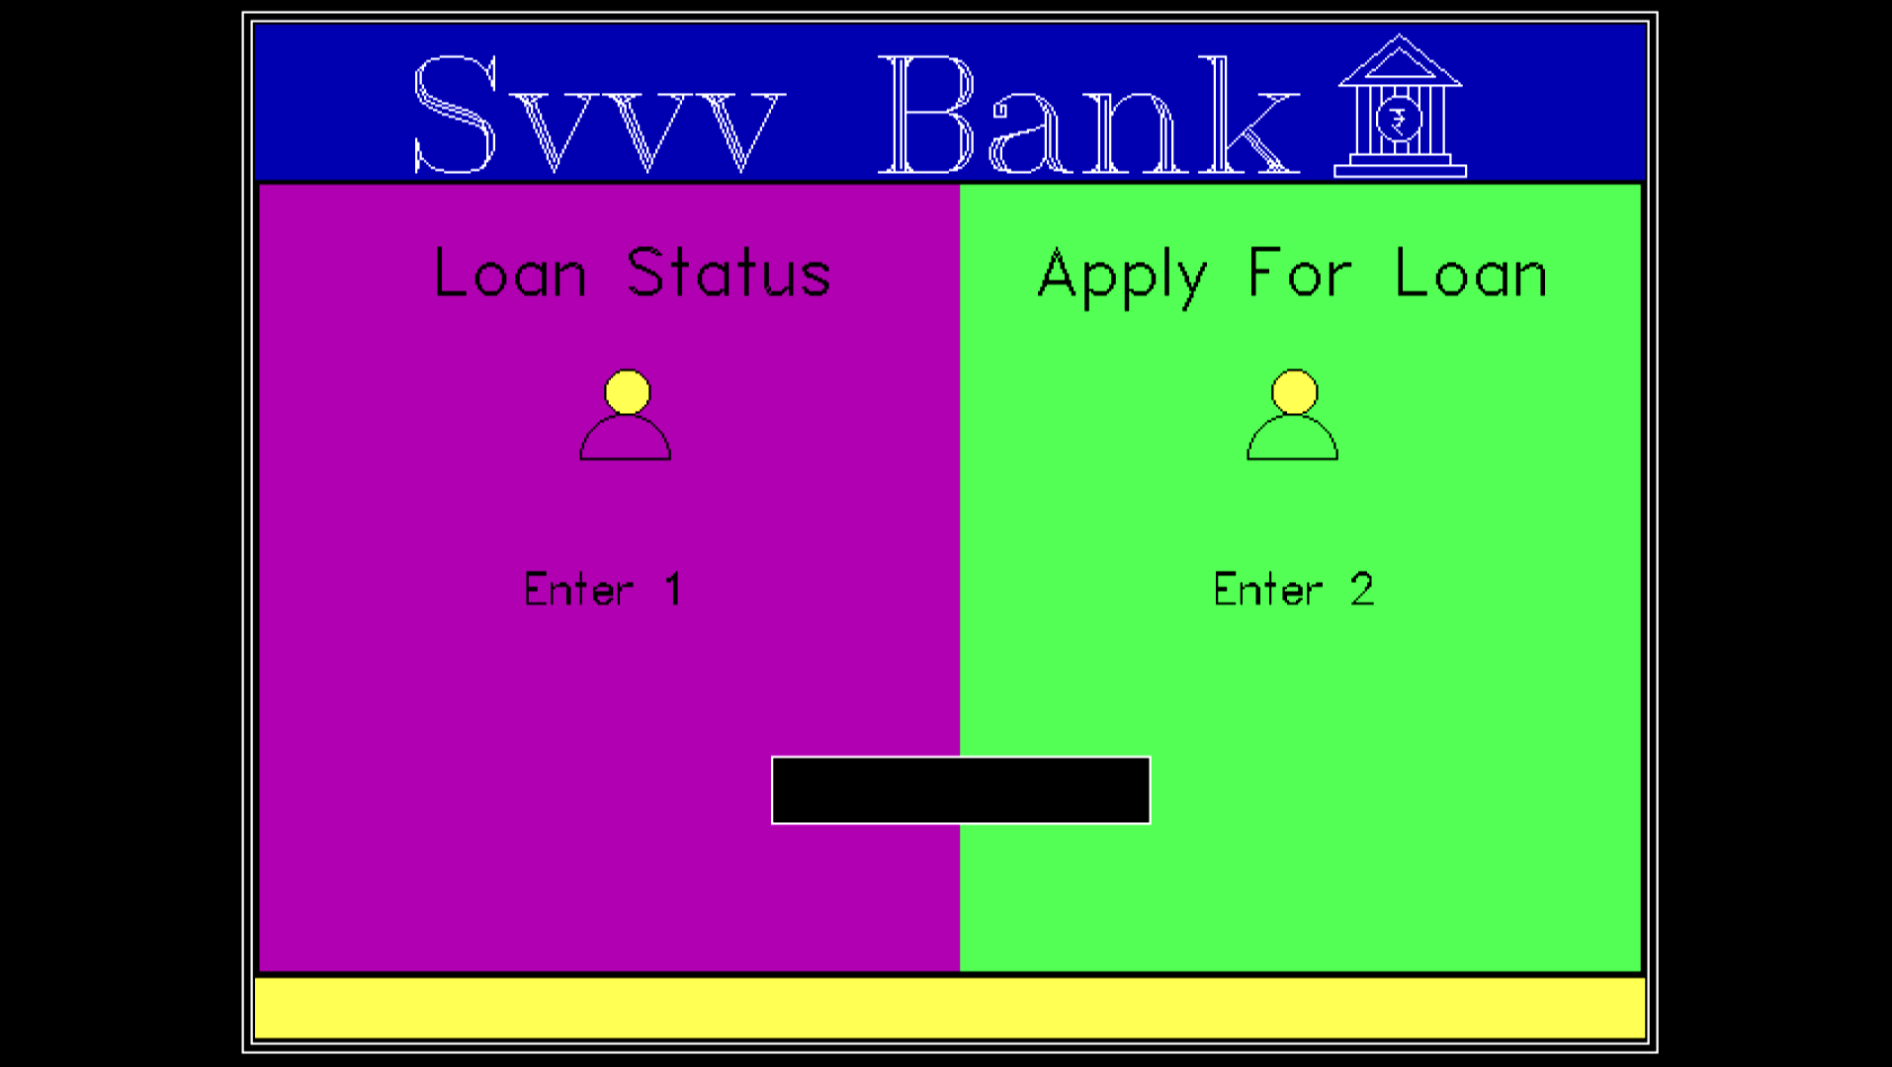

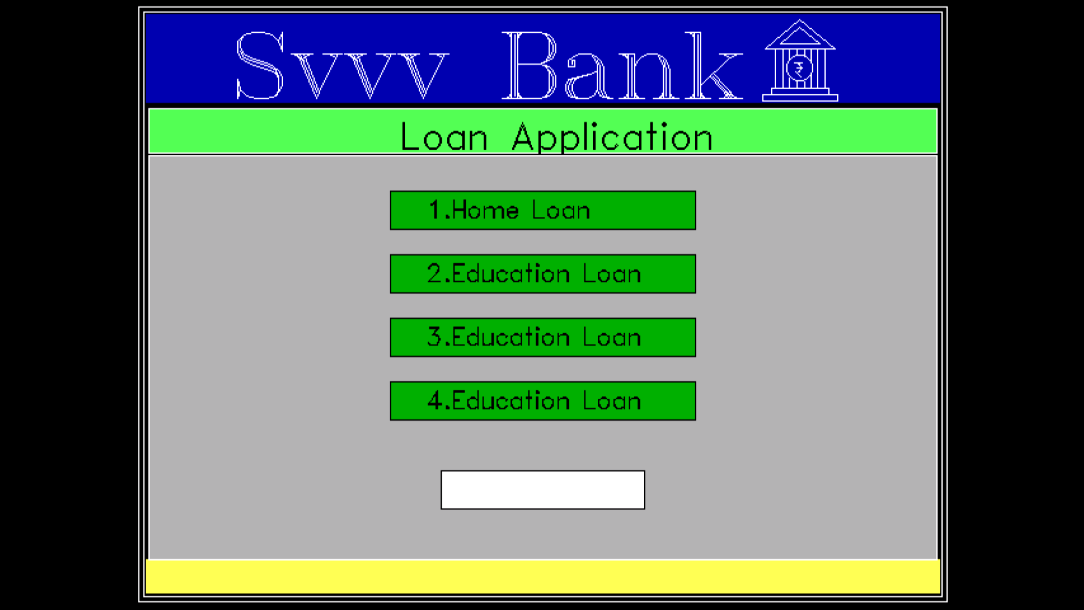

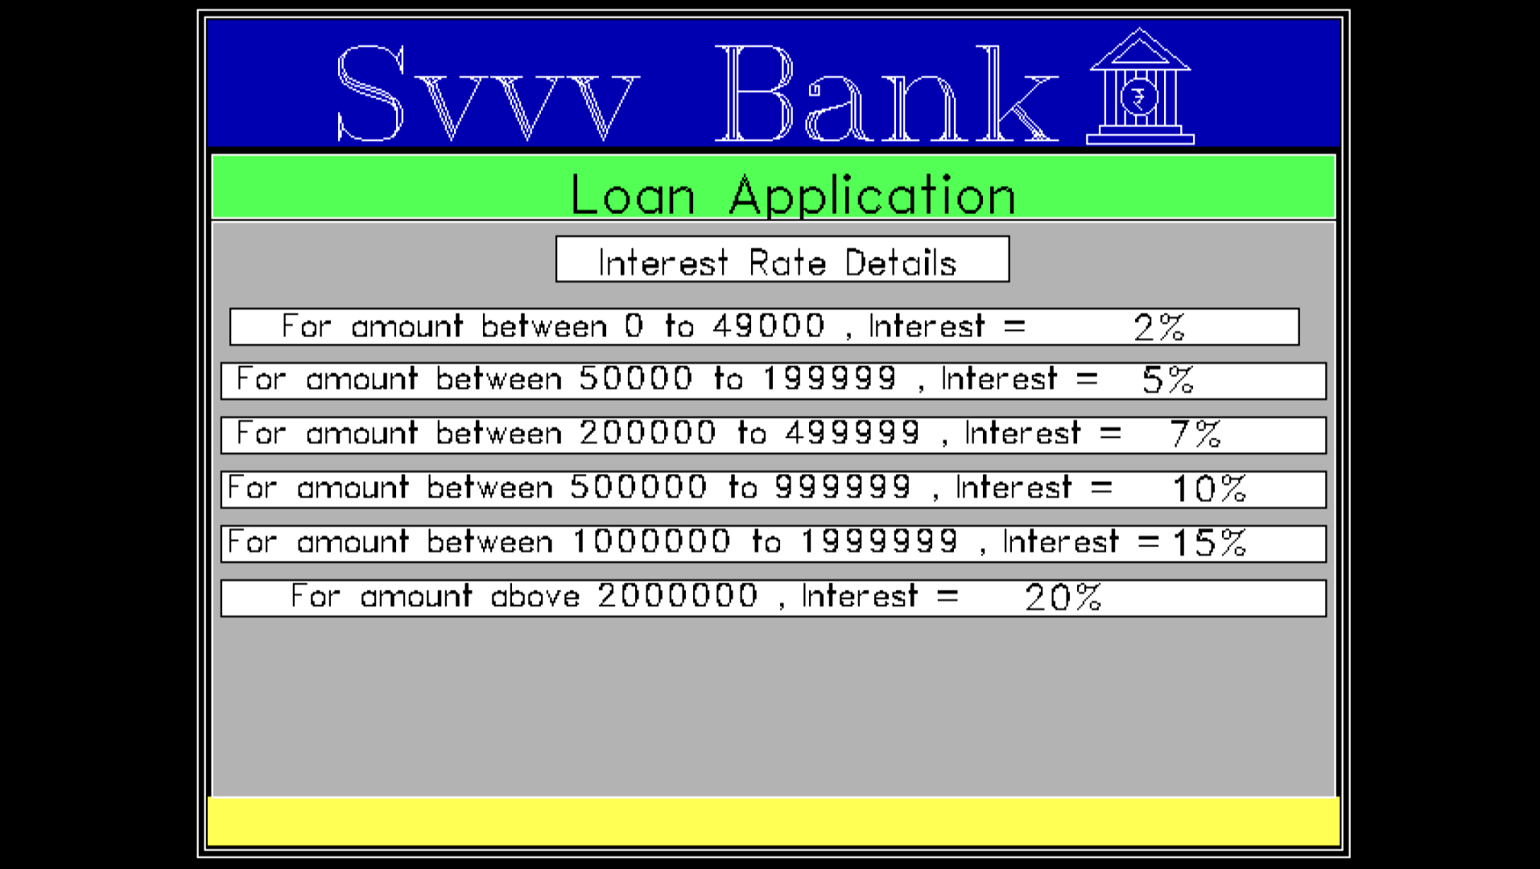

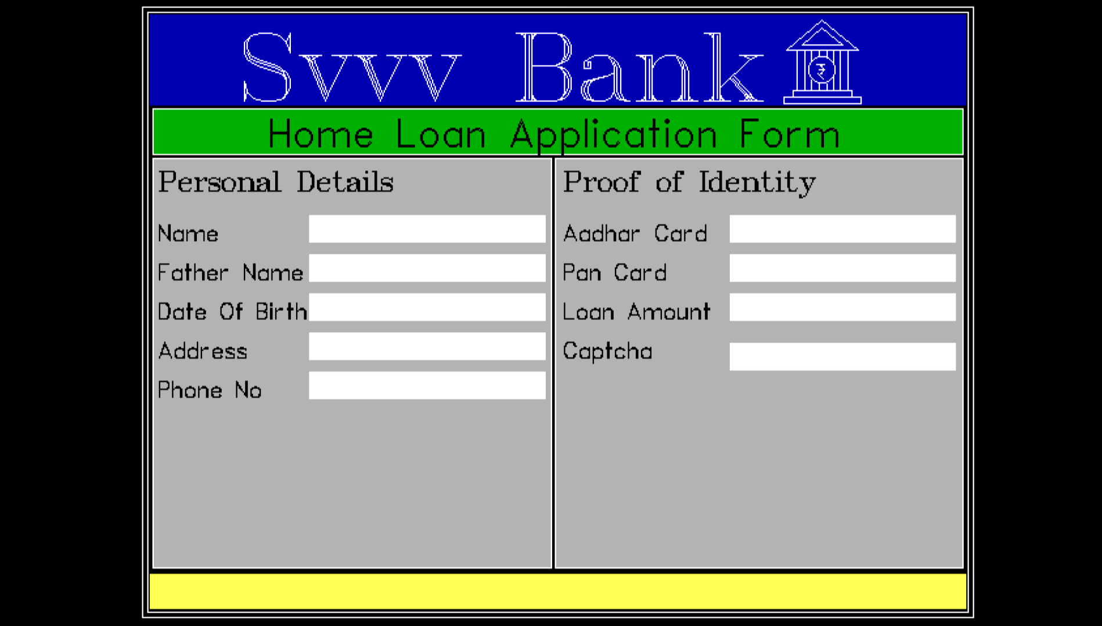

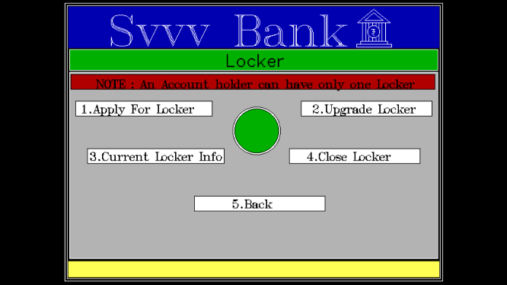
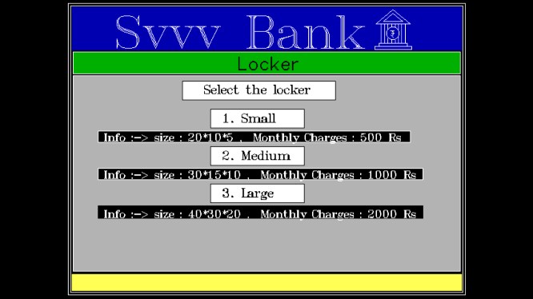

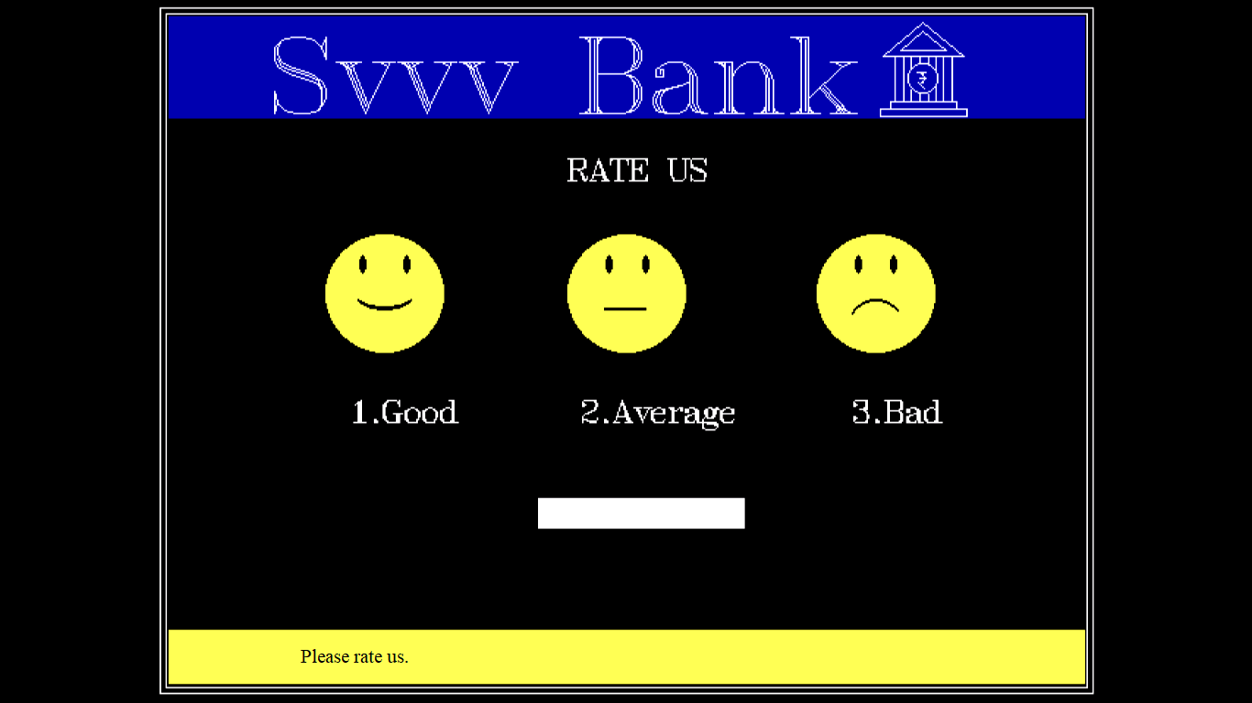
13.Conclusion

This project is developed to nurture the needs of the user in a banking sector by embedding all the tasks of transactions taking place in a bank.

THANK YOU

